# Management Review

## What is Management Review

**# Source**: **Chatgpt (GPT-5-Standard) at [8/14/2025]**

A **Management Review** in software testing is a **formal evaluation of the project’s progress, resources, and alignment with business goals**, conducted by management rather than technical peers.

It’s **not about finding bugs in code or test cases** — it’s about making sure the **project is on track** in terms of **scope, cost, schedule, risks, and compliance**.

## **Key Points**

**# Source**: **Chatgpt (GPT-5-Standard) at [8/14/2025]**

* **Objective:** To ensure that the **work product** (and the project itself) meets **business, contractual, and regulatory requirements**.
* **Who is involved:**
  + Project Manager / Test Manager
  + Senior Management / Stakeholders
  + Possibly QA Leads or Team Leads (to present reports)
  + Rarely the technical team in detail — focus is higher-level.
* **When it happens:** At **milestones** or key phases (e.g., end of test planning, after a major release cycle).

## **What’s Reviewed**

**# Source**: **Chatgpt (GPT-5-Standard) at [8/14/2025]**

1. **Progress Reports** → Are we on schedule?
2. **Budget and Resource Usage** → Are we overspending?
3. **Quality Metrics** → Defect trends, test coverage, pass/fail rates.
4. **Risk Management** → Are there unresolved high-priority risks?
5. **Compliance** → Are we following required standards (ISO, CMMI, FDA, HIPAA, etc.)?

## **Real-World Example in Testing**

**# Source**: **Chatgpt (GPT-5-Standard) at [8/14/2025]**

**Scenario:** Testing phase for an online banking system.

**Artifacts Reviewed:**

* Test execution summary (95% of planned tests executed, 5% blocked)
* Defect report (15 open critical defects, mostly in fund transfer module)
* Risk report (integration with payment gateway vendor delayed by 2 weeks)
* Budget usage (85% spent, 60% of testing done — risk of budget overrun)

**Management Action:**

* Approve additional budget for 2 more testers to speed up execution.
* Prioritize critical defect fixes before moving to UAT.
* Escalate vendor integration delay to contract team.

## **How It Differs from Other Reviews**

**# Source**: **Chatgpt (GPT-5-Standard) at [8/14/2025]**

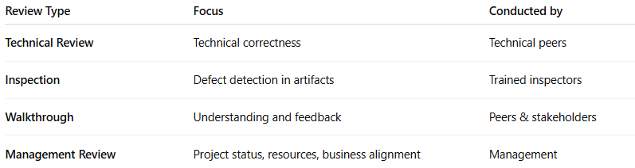

| **Review Type** | **Focus** | **Conducted by** |
| --- | --- | --- |
| **Technical Review** | Technical correctness | Technical peers |
| **Inspection** | Defect detection in artifacts | Trained inspectors |
| **Walkthrough** | Understanding and feedback | Peers & stakeholders |
| **Management Review** | Project status, resources, business alignment | Management |